***Software Requirements Specification***

**for**

***Culinary Coach***

*Prepared by Team 8*

*(Team Lead) Honorata Lubecka*

*Jair Espinoza*

*Joseph Onwe*

*Hayden Spelbring*

*Syracuse University CIS453*

*15 October 2023*

*Table of Contents*

1 Introduction 3

1.1 Purpose 3

1.2 Scope 3

1.3 Definitions 4

1.4 References 5

1.5 Overview 5

2 Overall Description 5

2.1 Product Perspective 5

2.2 Product Functions 5

2.3 Use Case Descriptions 6

2.3.1 Create Profile 6

2.3.2 Search for Recipe 7

2.3.3 Delete Recipe 8

2.3.4 Create Recipe 9

2.3.5 Input Ingredients 10

2.3.6 View Recipe 10

2.3.7 Rate Recipe 11

2.3.8 Delete Rating 12

2.3.9 Save or Favorite Recipe 13

2.3.10 Add Allergies 14

2.4 User Characteristics 14

2.5 User Constraints 14

3 Specific Requirements 15

3.1 Overview 15

3.2 Interface Requirements 15

3.3 System Features 15

3.3.1 Create Profile 15

3.3.2 Search for Recipe 17

3.3.3 Delete Recipe 19

3.3.4 Create Recipe 20

3.3.5 Input Ingredients 20

3.3.6 View Recipe 21

3.3.7 Rate Recipe 22

3.3.8 Delete Rating 23

3.3.9 Save or Favorite Recipe 23

3.3.10 Add Allergies 24

3.4 Performance Requirements 25

3.5 Design Constraints 26

3.6 Software System Attributes 26

3.7 Other Requirements 26

4 Appendix 27

4.1 Appendix A: Template Use Case Diagram 27

*Table of Figures*

Figure 1: Culinary Coach Class Diagram…………………………………………...…………….5

Figure 2: Culinary Coach Use Case Diagram……………………………………………………..6

Figure 3: Create Profile Activity Diagram…………………………………………………….....16

Figure 4: Search for Recipe Activity Diagram…………………………………………………...18

Figure 5: Delete Recipe Activity Diagram…………………………………………………….....19

Figure 6: Create Recipe Activity Diagram……………………………………………………….20

Figure 7: Input Ingredients Activity Diagram…………………………………………………....21

Figure 8: View Recipe Activity Diagram………………………………………………….…….22

Figure 9: Rate Recipe Activity Diagram……………………………………………………….….23

Figure 10: Save/Favorite Recipe Activity Diagram……………………………………………...24

Figure 11: Add Allergies Activity Diagram………………………………………………..…….25

*Table of Tables*

Table 1: Acronyms and Definitions……………………………………………………………….4

# 

# 1 Introduction

## 1.1 Purpose

Many people find themselves in a position where they want to bake at home instead of ordering takeout or buying pastries from the bakery for the fourth time in a week. It saves money and is a great life skill to have. But where to start? Some people mindlessly buy produce at the supermarket that then goes to waste because they don’t know what they could use it for. We want to change that. We hope to develop an app that will reduce produce waste, and improve a person’s confidence in the kitchen by cooking and baking for themselves. It’s the type of independence plenty of people are hungry for, and we want to offer a tool that will help them take the first step in the right direction. With easy to follow recipes and software that will help find recipes based on ingredients users already have available, this app will get more people out of their comfort zone and into the kitchen. We aim to get people excited to put on their metaphorical aprons and chef hats and explore the world of cooking and baking.

This app can solve issues such as:

* Recipe Discovery: Finding fun, delicious new meals can be time consuming and hard. This app can streamline that process and ensure users quickly find the recipes they are searching for.
* Ingredient Utilization: Low on Ingredients? This app can help you plan a meal with your limited resources. Or have ingredients you need to use up? This app can help match you with a recipe that will optimize usage of the ingredients you have so that you are reducing the amount of produce waste.
* Cooking Guidance: Detailed recipes and instruction can help beginners learn new recipes efficiently.
* Community Engagement: Adding a page for sharing meals allows for people to contribute to a supporting baking community.

## 1.2 Scope

This app allows people regardless of skills and experience to learn about baking. By simply inputting ingredients they have in their pantry people can learn to make pastry from various cultures without having to go to the store. Whether they are an intermediate or seasoned chef, looking to whip up a quick dessert for a party, gala, or group gathering: this baking app is here for any and every occasion.

The target audience of our app is anyone who:

* Home cooks and is looking for new baking recipes.
* Busy individuals or people looking for smart meal planning solutions.
* People with dietary restrictions are looking to eat healthier.
* New cooks looking to try out easier recipes.
* More advanced cooks looking to try new cuisines and dishes.
* Food enthusiasts looking to share their meals with the baking community.

This app will have the following features:

1. Recipe Database Input
   1. This the function where users can submit the type of baking ingredients they have and in hopes of coming out with a recipe
2. User Registration and Profiles (so people can save recipes)
   1. This is the user profile section where at every successful baking attempt the user can save the recipe they found, they can favorite, like and jot down a little journal of it tasted and turned out.
3. Ingredient-Based Recipe Search
   1. This is where the algorithm will go into the web and search up and find recipes using the ingredients that were provided and what ingredients the person is allergic of to filter out and not give any recipes they will be allergic to
4. Baking Guides
   1. After finding a recipe the app will return and provide the user with a detailed recipe of the pastry they can make, a step by step guide
5. Meal Rating
   1. After each successful bake the user can favorite, like, save, or jot down any notes they have about the cuisine they made. That way the user can go back and look at their notes of what they could have done differently or remind themselves of how it tastes.
6. An Interactive Page for Sharing Meals
   1. Users can share through various social media apps that they created a recipe using the app and that they recommend other people to use it as well and then post a picture of what they made.
7. Allergies Input
   1. User can share ingredients or allergies they have that way the system will never return a recipe with an ingredient they are allergic to and or find a replacement for that ingredient instead

## 1.3 Definitions

Table 1: Acronyms and Definitions

BDD: Block Definition Diagram

CD: Class Diagram

SRS: Software Requirements Specification

UCD: Use Case Diagram

UML: Unified Modeling Language

## 1.4 References

Sample SRS Template CIS 453

IEEE Std 830-1998 - IEEE Recommended Practice for Software Requirements Specifications - Revision of IEEE Std 830-1993

## 1.5 Overview

This document follows the recommended format specified in IEEE Std 830-1998 IEEE Recommended Practice for Software Specifications. For Section 3, the specific template A.5 for organizing information by feature is followed.

# 2 Overall Description

## 2.1 Product Perspective

The Culinary Coach app is intended to serve as a database for recipes with enhanced search and match functions that will allow users to find the right recipe for the skill level, ingredients available, and other contributing factors. This app will allow users to access the database as well as add to it and make comments to what is there; everything will be moderated by an admin that has the power to remove anything they rule unfit on the grounds of misconduct and general unacceptable online etiquette. Figure 1: System Block Diagram shows the system overview, using a Unified Modeling Language (UML) Class Diagram (CD) in lieu of a Block Definition Diagram (BDD).

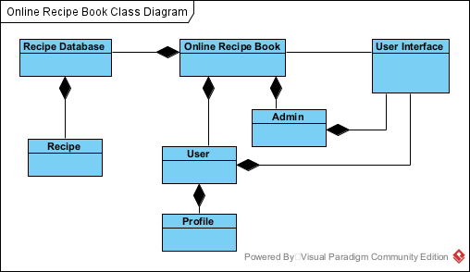

Figure 1: Culinary Coach Class Diagram

## 2.2 Product Functions

This document will show specific capabilities for how Culinary Coach will work using Unified Modeling Language (UML) and Use Case Diagram (UCD):

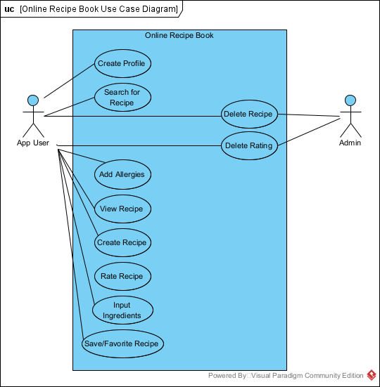

Figure 2: Culinary Coach Use Case Diagram

## 2.3 Use Case Descriptions

### 2.3.1 Create Profile

|  |  |
| --- | --- |
| **GENERAL CHARACTERISTICS** | |
| **Intent** | The purpose of this use case is to allow the user to create a profile that would enable them to save/favorite recipes and add recipes of their own; the database can be used without a profile, but does not include the added features of saving and rating recipes. |
| **Scope** | Culinary Coach Application |
| **Primary Actor** | App User |
| **Secondary Actors** | None |
| **Preconditions** | User has navigated to the website / app |
| **Trigger** | User clicks the Create Profile button |
| **Success Post Condition** | User Profile successfully completed |
| **Failed Post Condition** | No profile completed for the user |

|  |  |
| --- | --- |
| **MAIN SUNNY DAY SCENARIO** | |
| **Step** | **Action** |
| Start | This user case starts with the user selecting the Create Profile button found on the home screen of the website / app |
| 1 | The user interface display prompts the user to enter their first and last name, email, and to create a username and password. |
| 2 | User enters their first and last name, email, and creates a username and password. |
| 3 | System checks that all required fields have been completed and are valid, and that the username is unique. |
| 4 | System creates a profile for the user. |
| 5 | Use case ends with the user interface displaying a Login page, prompting the user to Login. |

|  |  |
| --- | --- |
| **MAIN RAINY DAY SCENARIO** | |
| **Step** | **Action** |
| Start | This use case begins and ends with a failure to allow the user to select the Create Profile button. |

### 2.3.2 Search for Recipe

|  |  |
| --- | --- |
| **GENERAL CHARACTERISTICS** | |
| **Intent** | Allows the user to freely search the database of recipes. An option exists for the user to input ingredients they wish the recipe to include, but this can be omitted and the user can just search the database that is organized in no particular order; the idea is to get the user to try something new, hence there being no order. A search bar is included if the user is looking for something specific. |
| **Scope** | Culinary Coach Application; Web Searching |
| **Primary Actor** | App User |
| **Secondary Actors** | Google/Internet |
| **Preconditions** | User has navigated to the website / app, has possibly logged in |
| **Trigger** | User has selected the Search For Recipe button located on the homescreen of the website / app |
| **Success Post Condition** | A list of possible recipes will appear on the user’s display |
| **Failed Post Condition** | Error message Please Try Again Later page displays |

|  |  |
| --- | --- |
| **MAIN SUNNY DAY SCENARIO** | |
| **Step** | **Action** |
| Start | User Interface displays a home screen with options to Login, Search for Recipe, etc. |
| 1 | Users may choose to login in, otherwise they select the Search for Recipe Option. |
| 2 | Display shows the list of recipes found in the database of recipes. |
| 3 | Users may choose the Input Ingredients feature and select the ingredients they wish the recipe to include. |
| 4 | System finds recipes that include the ingredients listed, in order from most ingredients used to least ingredients used. |
| 5 | User interface displays the recipes found to include the desired ingredients. |

|  |  |
| --- | --- |
| **MAIN RAINY DAY SCENARIO** | |
| **Step** | **Action** |
| Start | User Interface displays a home screen with options to Login, Search for Recipe, etc. |
| 1 | User may choose to login in, otherwise they select the Search for Recipe Option |
| 2 | User Interface fails to display the list of recipe found in the database of recipes, error message displayed saying Please Try Again Later |

### 2.3.3 Delete Recipe

|  |  |
| --- | --- |
| **GENERAL CHARACTERISTICS** | |
| **Intent** | The Delete Recipe use case allows the original creator of this recipe as well as the Admin of the website / app to delete a recipe that is in the database. This could be for the purpose of no longer wishing to share a recipe, or because there is inappropriate information found within the recipe, or any number of reasons. |
| **Scope** | Culinary Coach Application |
| **Primary Actor** | Admin |
| **Secondary Actors** | App User |
| **Preconditions** | Recipe exists in the database and the user has navigated to the list of recipes. |
| **Trigger** | The Admin or original creator select the Delete Recipe option |
| **Success Post Condition** | Recipe is removed from the database and the user is returned to the list of recipes. |
| **Failed Post Condition** | Recipe is not removed and remains in the database. |

### 2.3.4 Create Recipe

|  |  |
| --- | --- |
| **GENERAL CHARACTERISTICS** | |
| **Intent** | The Create Recipe use case allows the user to become an original creator and share one of their recipes for anyone to make, free of charge. A detailed step by step guideline will be provided and a list of ingredients needed to create the dish will also be required. |
| **Scope** | Culinary Coach Application |
| **Primary Actor** | App User |
| **Secondary Actors** | Authorized Users for Approval |
| **Preconditions** | Input Ingredient Use Case, View Recipe Use Case, Search For Recipe Use Case |
| **Trigger** | User Clicks on the Create Recipe |
| **Success Post Condition** | User fills out the recipe template and submits it to the system where it will create the user a recipe. |
| **Failed Post Condition** | Template does not load or recipe is unable to be submitted and uploaded |

|  |  |
| --- | --- |
| **MAIN SUNNY DAY SCENARIO** | |
| **Step** | **Action** |
| Start | The user loads the app and wants to create a recipe to the application to share to the community or favorite. |
| 1 | The user selects the open to create a recipe. |
| 2 | The user then clicks the “create” button and clicks on their desired ingredients to create their recipe. |
| 3 | The recipe is created and saved under the user’s profile.and shared with the community. |

|  |  |
| --- | --- |
| **MAIN RAINY DAY SCENARIO** | |
| **Step** | **Action** |
| Start | The user clicks the button to create a recipe and the button fails to work. |
| 1 | The user receives a notification instructing them to try again. |

### 2.3.5 Input Ingredients

|  |  |
| --- | --- |
| **GENERAL CHARACTERISTICS** | |
| **Intent** | The Input Ingredient use case allows users to input a list of ingredients they currently have at home that will then be used to cross reference and return a culinary combinations of possibilities of what can be made |
| **Scope** | Culinary Coach |
| **Primary Actor** | User |
| **Secondary Actors** | Internet/Google |
| **Preconditions** | Working text box to type to input ingredients and auto correct incase ingredients are misspelled |
| **Trigger** | The user selects input ingredients |
| **Success Post Condition** | The system will begin to cross reference using ingredients from the list |
| **Failed Post Condition** | An error message appears |

|  |  |
| --- | --- |
| **MAIN SUNNY DAY SCENARIO** | |
| **Step** | **Action** |
| Start | The user loads the app and wants to find a recipe given the ingredients they have, they select the insert recipe search bar |
| 1 | The user types all the ingredients they have available |
| 2 | The user submits the ingredients |
| 3 | The system accept the ingredients |
| 4 | The system moves to the Find Recipe use Case |

|  |  |
| --- | --- |
| **MAIN RAINY DAY SCENARIO** | |
| **Step** | **Action** |
| Start | The system is unable to understand the recipes provided and returns a “please try that again” message |

### 2.3.6 View Recipe

|  |  |
| --- | --- |
| **GENERAL CHARACTERISTICS** | |
| **Intent** | The system provides the user with recipes containing all the ingredients they provided and filters out any and every recipe with an ingredient the user is allergic to |
| **Scope** | Culinary Coach |
| **Primary Actor** | User |
| **Secondary Actors** | Internet |
| **Preconditions** | Input Ingredients, Add Allergies, System Internet, Search for Recipe, Upload Recipe |
| **Trigger** | User Successful Searches for Recipes |
| **Success Post Condition** | The user is provided with recipes containing all the ingredients they provided and none with ingredients they are allergic to |
| **Failed Post Condition** | Recipes are unable to load, register, or appear |

|  |  |
| --- | --- |
| **MAIN SUNNY DAY SCENARIO** | |
| **Step** | **Action** |
| Start | The User has successful imputed a list of ingredients they have and the system has successful performed find recipe using the ingredients provided |
| 1 | The system displays unique recipes that can be made using the ingredients provided |
| 2 | When clicked on the recipe expands from an image to show steps and procedures needed to create that dish |

|  |  |
| --- | --- |
| **MAIN RAINY DAY SCENARIO** | |
| **Step** | **Action** |
| Start | The page fails to load and nothing is displayed |

### 2.3.7 Rate Recipe

|  |  |
| --- | --- |
| **GENERAL CHARACTERISTICS** | |
| **Intent** | The Rate Recipe use case allows users of Culinary Coach to rate dishes they were provided for reminded of what they would have done different or read the advice of others users who created that dish |
| **Scope** | Culinary Coach Application |
| **Primary Actor** | App User |
| **Secondary Actors** | Internet |
| **Preconditions** | View Recipe |
| **Trigger** | While the user is on Viewing Recipe Case, there will be a section dedicated for reading reviews |
| **Success Post Condition** | The user is shown reviews from users all around the world and is shown in the comment with the most amount of likes, and can sort reviews based on oldest, newest, or top comment |
| **Failed Post Condition** | Reviews are unable to load or button doesnt work |

|  |  |
| --- | --- |
| **MAIN SUNNY DAY SCENARIO** | |
| **Step** | **Action** |
| Start | User viewing an already existing recipe and selects the rate recipe section |
| 1 | The user writes a review on the recipe they recently view |
| 2 | The user publishes the review |
| 3 | The System accepts the review |
| 4 | The Review is no able to be seen by other users |

|  |  |
| --- | --- |
| **MAIN RAINY DAY SCENARIO** | |
| **Step** | **Action** |
| Start | The review page fails to load |
| 1 | A message appears notifying the user to try again. |

### 2.3.8 Delete Rating

|  |  |
| --- | --- |
| **GENERAL CHARACTERISTICS** | |
| **Intent** | The Delete Rating use case allows the original creator of the rating as well as the Admin of the website / app to delete a rating that is associated with a recipe. This could be for the purpose of no longer wishing to share the rating, or because there is inappropriate information found within the rating, or any number of reasons. |
| **Scope** | Culinary Coach Application |
| **Primary Actor** | Admin |
| **Secondary Actors** | App User |
| **Preconditions** | Rating is associated with a recipe and the user has navigated to the particular recipe associated with the rating. |
| **Trigger** | The Admin or original creator select the Delete Rating option |
| **Success Post Condition** | Rating is removed from the database and the user is returned to the current recipe. |
| **Failed Post Condition** | Rating is not removed from the associated recipe and remains associated with the recipe. |

|  |  |
| --- | --- |
| **MAIN SUNNY DAY SCENARIO** | |
| **Step** | **Action** |
| Start | The user selects an open to delete a rating on a recipe. |
| 1 | The rating is deleted from the recipe. |

|  |  |
| --- | --- |
| **MAIN RAINY DAY SCENARIO** | |
| **Step** | **Action** |
| Start | The rating does not delete itself. |

### 2.3.9 Save or Favorite Recipe

|  |  |
| --- | --- |
| **GENERAL CHARACTERISTICS** | |
| **Intent** | The Favorite Recipe use case allows users to save/favorite recipes that way they can be stored for later and easy associable for future uses |
| **Scope** | Culinary Coach Application |
| **Primary Actor** | User |
| **Secondary Actors** | System |
| **Preconditions** | View Recipe Use Case |
| **Trigger** | The user selects “favorite” or “save” option |
| **Success Post Condition** | Recipe is saved, stored in user profile and notified on its success |
| **Failed Post Condition** | Returned to view recipe without saving it the user profile, |

|  |  |
| --- | --- |
| **MAIN SUNNY DAY SCENARIO** | |
| **Step** | **Action** |
| Start | The user selects the save/favorite button. |
| 1 | The recipe is saved to the user’s saved/favorite recipes. |

|  |  |
| --- | --- |
| **MAIN RAINY DAY SCENARIO** | |
| **Step** | **Action** |
| Start | The favorite button does not work. |

### 2.3.10 Add Allergies

|  |  |
| --- | --- |
| **GENERAL CHARACTERISTICS** | |
| **Intent** | The add allergies use case allows users to input a list of ingredient, products, chemicals, or scents they they are allergic to and any time the user looks for a recipe, the system will never return a recipe with an ingredient they are allergic to |
| **Scope** | Culinary Coach |
| **Primary Actor** | User |
| **Secondary Actors** | Internet/Google & System Memory |
| **Preconditions** | Storage and memory allocation for the system to remember allergies and user profile where this feature will be located |
| **Trigger** | The user selects input allergies |
| **Success Post Condition** | The system will save what the user is allergic to and will refer to it any time a recipe is searched for |
| **Failed Post Condition** | The system only saves allergies and nevers uses it to check if a recipe contains that ingredient |

|  |  |
| --- | --- |
| **MAIN SUNNY DAY SCENARIO** | |
| **Step** | **Action** |
| Start | The System successfully displays User Info and there will be a button labeled add allergies |
| 1 | The User Selects Add Allergies |
| 2 | A Prompt is brought up asking the user insert allergies |
| 3 | The user submits a list or a single item they are allergic to |
| 4 | The system successfully stores this information for future use |
| 5 | The system will no longer pull recipes containing any of these allergies |

|  |  |
| --- | --- |
| **MAIN RAINY DAY SCENARIO** | |
| **Step** | **Action** |
| Start | The Add Allergies button does not work |

## 2.4 User Characteristics

Not completed at this time.

## 2.5 User Constraints

Not completed at this time.

# 3 Specific Requirements

## 3.1 Overview

Not completed at this time.

## 3.2 Interface Requirements

Not completed at this time.

## 3.3 System Features

### 3.3.1 Create Profile

#### 3.3.1.1 Introduction/Purpose of Feature

This feature will allow users to create a profile that will enable them to save/favorite content and rate recipes. Their stored profile information will include any saved recipes as well as records of ratings/comments associated with recipes. They will also be able to view the ratings/comments left on their uploaded recipes (if any exist) by other users.

#### 3.3.1.2 Stimulus/Response Sequence

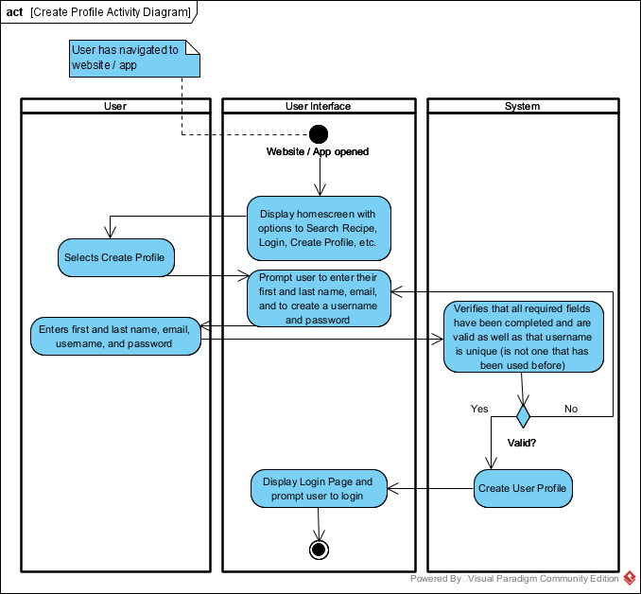

Figure 3: Create Profile Activity Diagram

#### 3.3.1.3 Associated Functional Requirements

3.3.1.3.1 The user interface shall allow the View the Create Profile option as one of the options displayed on the homescreen.

3.3.1.3.2 The system shall allow users to select the Create Profile option from the list of options displayed on the homescreen.

3.3.1.3.3 The system shall redirect the user back to the profile creation page if any of the credentials are invalid, i.e. if the user chooses a username that already exists.

3.3.1.3.4 The user interface shall display an error message if profile creation has failed, i.e. if the user chooses a username that already exists (not included in Figure 3).

3.3.1.3.5 The system shall create a user profile should all the data input by the user be valid.

3.3.1.3.6 The user interface shall allow the user to view the login screen upon the user profile successfully being created.

### 3.3.2 Search for Recipe

#### 3.3.2.1 Introduction/Purpose of Feature

This feature will allow users to search for recipes in the online database of recipes that includes recipes from sources pulled from the internet. Additional features are related to this use case, as the user has the ability to search for specific recipes using the search bar as well as select ingredients they wish to appear in the recipe. A simplified activity diagram is shown in 3.3.2.2.

#### 3.3.2.2 Stimulus/Response Sequence

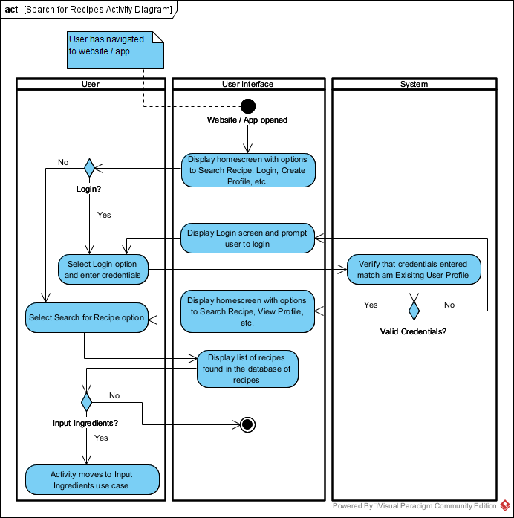

Figure 4: Search for Recipe Activity Diagram

#### 3.3.2.3 Associated Functional Requirements

3.3.2.3.1 The user interface shall allow users to view the list of recipes in the database. 3.3.2.3.2 The system shall allow users to search for recipes with the use of a search bar.

3.3.2.3.3 The system shall allow users to input ingredients for the recipe and generate a list of relevant recipes given the user input.

3.3.2.3.4 The user interface shall allow the user to click on a recipe to view it (see 3.3.6).

### 3.3.3 Delete Recipe

#### 3.3.3.1 Introduction/Purpose of Feature

This feature will allow users to delete recipes they have created.

#### 3.3.3.2 Stimulus/Response Sequence

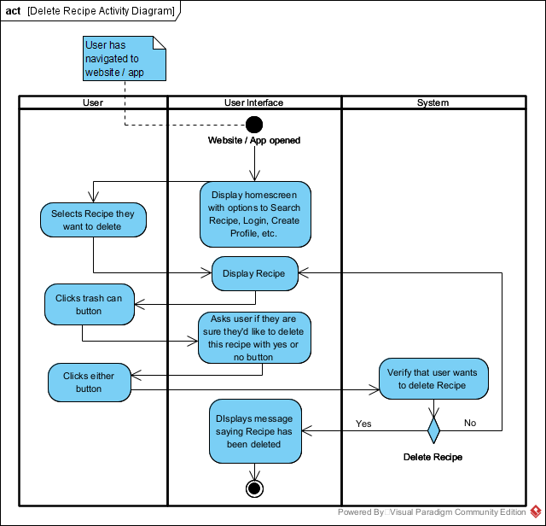

Figure 5: Delete Recipe Activity Diagram

#### 3.3.3.3 Associated Functional Requirements

3.3.3.3.1 The user interface shall allow users to view recipes.

3.3.3.3.2 The user interface shall ask the user if they’d like to delete their recipe.

3.3.3.3.3 The system shall verify whether the user would like to delete their recipe.

### 3.3.4 Create Recipe

#### 3.3.4.1 Introduction/Purpose of Feature

This feature will allow users to create recipes.

#### 3.3.4.2 Stimulus/Response Sequence

#### 

Figure 6: Create Recipe Activity Diagram

#### 3.3.4.3 Associated Functional Requirements

#### 3.3.4.3.1 The newly created recipe shall be saved in the user’s recipe collection.

#### 3.3.4.3.2 The user shall have the option to specify the cooking time, ingredients, etc.

#### 3.3.4.3.3 The user shall be able to upload an image of their recipe.

#### 3.3.4.3.4 The user shall be able to add steps to their instruction for the recipe.

### 3.3.5 Input Ingredients

#### 3.3.5.1 Introduction of inputting ingredients

The User shall input a list of ingredients they have in order to be returned an assessment of possible combinations of meals they can cook with.

#### 3.3.5.2 Stimulus/Response Sequence

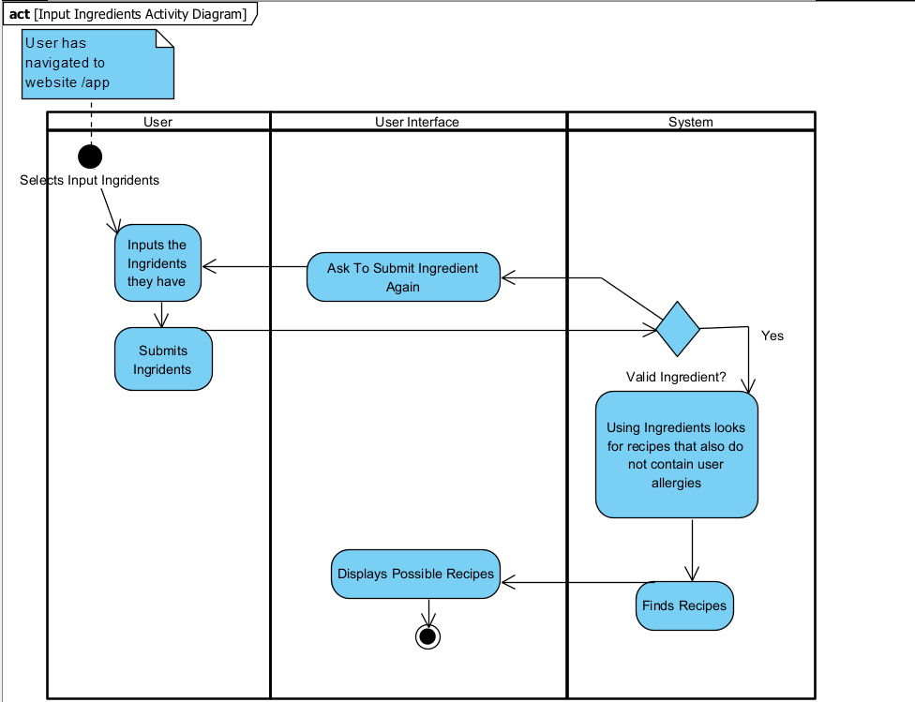

Figure 7: Input Ingredients Activity Diagram

#### 3.3.5.3 Associated Functional Requirements

3.3.5.3.1 The user interface shall ask users to input ingredients they have

3.3.5.3.2 The System shall accept and understand ingredients provided

3.3.5.3.3 The System shall use this information for the view recipe use case

### 3.3.6 View Recipe

#### 3.3.6.1 Introduction/Purpose of Feature

This feature will allow the user to view the recipe they click on. Doing so will display the recipe on the user interface, detailing everything associated with the recipe from the ingredients required to the prep time and potentially photos of what the final product will look like.

#### 3.3.6.2 Stimulus/Response Sequence

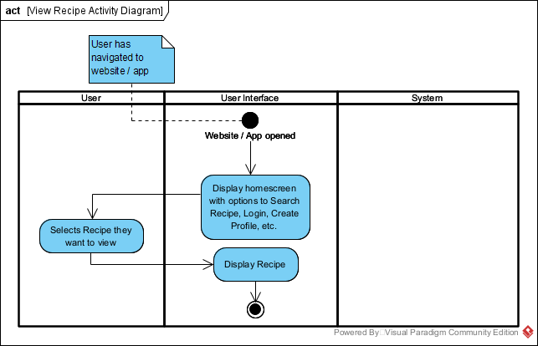

Figure 8: View Recipe Activity Diagram

#### 3.3.6.3 Associated Functional Requirements

3.3.6.3.1 The user interface shall display recipes upon the users request

3.3.6.3.2 The user shall be able to view the recipe they please as any given moment

### 3.3.7 Rate Recipe

#### 3.3.7.1 Introduction/Purpose of Feature

This feature will allow users to rate recipes of their choosing. It will allow users to leave a rating on a scale from 1 to 5 as well as leave a written comment. Ratings will be monitored by the admin and a user may request to have a rating removed from a recipe that they have uploaded. A user may also remove a rating that they have left on someone else’s recipe.

#### 3.3.7.2 Stimulus/Response Sequence

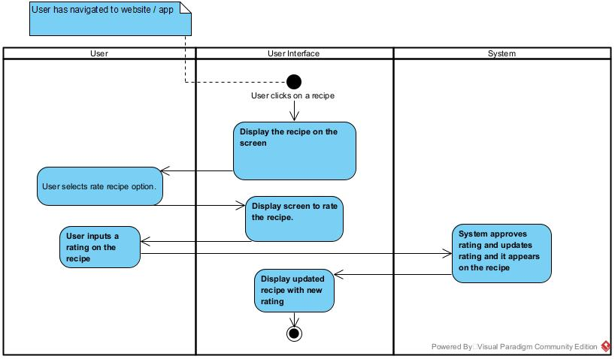

Figure 9: Rate Recipe Activity Diagram

#### 3.3.7.3 Associated Functional Requirements

#### 3.3.7.3.1 The system shall allow users to rate recipes on a scale (ie. 1 to 5 stars).

#### 3.3.7.3.2 The system shall display and calculate the average rating for each recipe.

#### 3.3.7.3.3 The user interface shall allow the user to view the rating for each recipe .

### 3.3.8 Delete Rating

#### 3.3.8.1 Introduction/Purpose of Feature

This feature will allow users to delete their ratings on recipes.

#### 3.3.8.2 Stimulus/Response Sequence

Omitted for this submission.

#### 3.3.8.3 Associated Functional Requirements

Omitted for this submission.

### 3.3.9 Save or Favorite Recipe

#### 3.3.9.1 Introduction/Purpose of Feature

This feature will allow users the ability to favorite or save a recipe to store for later. A list of favorited/saved recipes will be available for viewing on the users’ profile page.

#### 3.3.9.2 Stimulus/Response Sequence

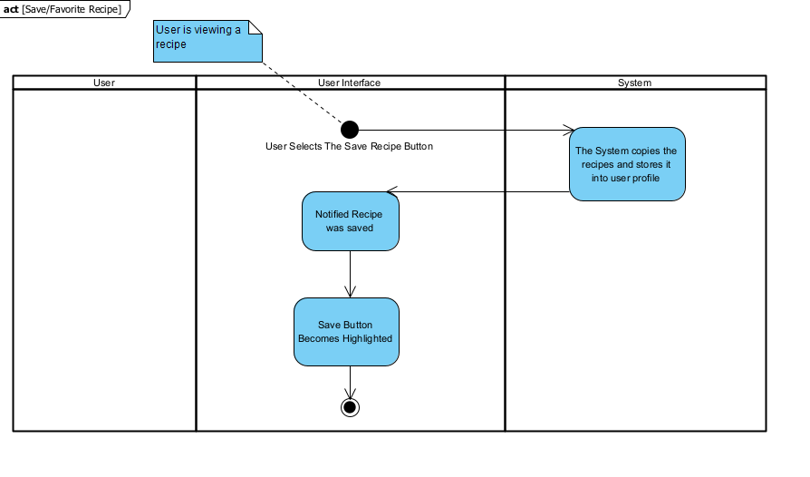Figure 10: Save/Favorite Recipe Activity Diagram

#### 3.3.9.3 Associated Functional Requirements

3.3.9.3.1 The user interface shall notify when a recipe has been saved

3.3.9.3.2 The system shall stored “Saved” recipes on user profile for ease of accessibility

3.3.9.3.2 The user interface will become highlighted once

### 3.3.10 Add Allergies

#### 3.3.10.1 Introduction/Purpose of Feature

This feature will allow users to add allergy information to their recipes. This will allow other users to be aware of potential allergens present in the recipe.

#### 3.3.10.2 Stimulus/Response Sequence

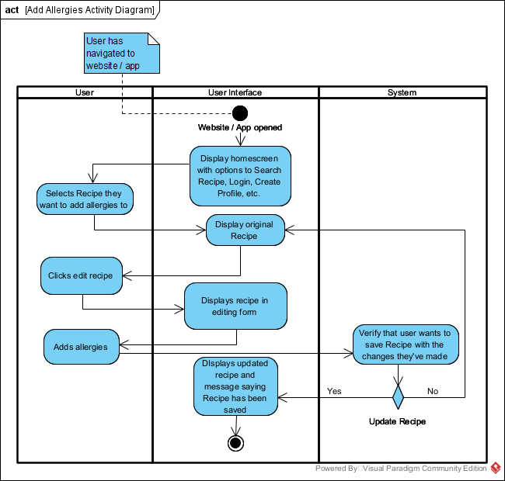

Figure 11: Add Allergies Activity Diagram

#### 3.3.10.3 Associated Functional Requirements

#### 3.3.10.3.1 The user interface shall allow users to view their recipe at any given moment.

3.3.10.3.2 The user shall be able to edit their recipe.

3.3.10.3.3 The user interface shall display the users recipe in editing mode.

3.3.10.3.4 The system shall verify if the user would like to save their edits to the recipe.

3.3.10.3.5 The user interface shall display the user updated recipe after changes have been made.

## 3.4 Performance Requirements

Not completed at this time.

## 3.5 Design Constraints

Not completed at this time.

## 3.6 Software System Attributes

Not completed at this time.

## 3.7 Other Requirements

Not completed at this time.

The following general requirements are taken from the original submission of the Project Description and are included for now as reference as the product definition becomes more developed.

Functional requirements:

* The app shall allow users to upload recipes.
* The app shall allow users to view recipes.
* The app shall allow users to view previously used recipes (store user activity history).
* The app must allow users to enter ingredients they wish to use in a recipe.
* The app must allow the user to select the yield size of the recipe, and the app must compute the quantity of each ingredient needed.
* The app must allow users to leave feedback in the form of a rating and comments.
* The app must allow users to suggest alternate ingredient options for a recipe.

Non-functional requirements:

* Only the site manager can remove a recipe from the database.
* The system will run on any OS, both PC and mobile.
* The system should be able to add recipes to an existing list of recipes.
* The system should be able to identify repeat recipes and combine them together by listing any variations in methods or ingredients.
* The system should distinguish between metric and imperial units of measures.
* The system should not allow users to input any personal information.

# 

# 4 Appendix

## 4.1 Appendix A: Template Use Case Diagram

|  |  |
| --- | --- |
| GENERAL CHARACTERISTICS | |
| Intent | [a summary statement of the purpose of the use case] |
| Scope | [one of: company, name of system under design being considered black box, or another as appropriate]  <[owning use case package]> |
| Primary Actor | [role name for the primary actor, <optional description>] |
| Secondary Actors | [role names of other actors (could be systems) relied upon to accomplish use case] |
| Preconditions | [what we expect is already the state of the world] <[pointer to precondition object model]> |
| Trigger | [the event that starts the use case] |
| Success Post Condition | [the state of the world upon successful completion]  <[pointer to post condition object model]> |
| Failed Post Condition | [the state of the world if use case abandoned]  <[pointer to post condition object model]> |

|  |  |
| --- | --- |
| MAIN SUNNY DAY SCENARIO | |
| Step | Action |
| S | [description in words of the main success scenario]  <[pointer to scenario and or activity diagrams for the main success scenario]> |
| 1 | ["This use case starts when …" followed by the trigger.] |
| 2 | [step description… <"included" use case pointer>] |
| 3 | [step description… <"included" use case pointer>] |
| 4 | ["This use case ends when …" the final step in main success scenario.] |

|  |  |
| --- | --- |
| MAIN RAINY DAY SCENARIO | |
| Step | Action |
| S | [description in words of the main success scenario]  <[pointer to scenario and or activity diagrams for the main success scenario]> |
| 1 | ["This use case starts when …" followed by the trigger.] |
| 2 | [step description… <"included" use case pointer>] |
| 3 | [step description… <"included" use case pointer>] |
| 4 | ["This use case ends when …" the final step in main success scenario.] |